BlueCrest College Ghana

(Affiliated with University of Education Winneba)





5TH JUNE, 2014

MOBILE PHONE ANTI THEFT SYSTEM

(PROJECT DOCUMENTATION)

NAME: AFEEZ OLAWALE ISHOLA PROGRAM: BSC IT

REG NUMBER: 30021220507 LEVEL: 400 (SEMESTER 8)

PROJECT SUPERVISOR: Mr. PETER ODONKO NUMBER: 0544902114

# Preliminary Information

# Title Page

## Certificate

## Dedication

## Acknowledgement

## Table of content

## List of tables

## List of figures

## List of abbreviations

## Abstract

# Chapter 1

## Introduction

## Problem Statement

## Background of Project

## Project Scope

## Architecture

## Significance

## Chapter Organization

# Chapter 2 (Literature Review)

# Chapter 3

## Objective, Activities and Methods, Deliverables

# Chapter 4 (Requirement Analysis)

## Introduction

## Existing System

## Proposed System

## Feasibility

## Technology

## Hardware

## Software

## Economical

# Chapter 5 (Design Techniques)

## Introduction

## Use Case Diagrams

## Class Diagrams

## Enhanced Entity Relationship Diagrams

# Chapter 6 (Implementation Design)

# End user Documentation Guide

# Conclusion

**Abstract**

Mobile Anti-Theft system is an application based on Android used for tracing back stolen or lost mobile, once my application is installed onto a mobile phone and an alternate number is fed into the software (MATS).

The owners SIM card gets registered in the database, whenever phone is rebooted MATS is invoked in stealth mode and verifies whether if the SIM card present in mobile phone is of owner.

If the SIM belongs to owner (registered in database), the software doesn’t do any activity, If SIM is been changed and that SIM is not registered in the database then, MATS sends a message to the alternative mobile number (friends / relatives number which is been saved while installing the application) in stealth mode and starts listening for incoming SMS messages.

Now if owner send a SMS request to MATS asking for GPS co-ordinates, MATS would do so, Since My application is based on GOOGLE Android operating system our system would send the complete address (postal address) as to a where the mobile is.

# CHAPTER 1

**1.1 Introduction**

Today, we live in a world of virtual reality. It makes sense to say that none of us can live without our computers and mobiles and other gadgets.

With mobile devices becoming more and more essential to survive with, people have started storing more and more confidential data and information on their mobile devices.

In most cases, it is the information that happens to be more important than the computer or mobile itself.

So, what happens if your mobile or laptop gets stolen or is lost? Wouldn't it be terrible to know that an unauthorized user has complete access to your information? Taking all of this in mind, Mobile Anti-Theft system is developed.

While some stolen mobile phones will wind up in pawn shops, sold on the street corners or in online classifieds, the vast majority of stolen devices are now being shipped internationally.

International markets (particularly countries in Africa, Latin America, and Asia pacific) pay a premium for Smartphone’s, with the high demand pushing the prices way up made nearly $4 million in 8 months as middleman selling phones to Hong Kong, where they can fetch as much as $2000 per phone. (Arieanna Schwebber).

Even in Nigeria and Ghana most Mobile users are alarmed at the rate of GSM phone theft in the country, the experience pales into nothing when compared with happens in South Africa.

South Africa easily qualifies as the headquarters of telephone theft on the African continent.

In the average, Vodacom and MTN receives about 10,000 phone theft a month, no thanks to the activities of GSM phone thieves in down town Johannesburg, Lagos and Accra who make life difficult for cell phone subscribers. [1]

MATS will consist of a number of essential anti-theft features that many other devices do not contain.

It will use android built in feature to retrieve the information about the change of SIM on your mobile phone incase its get lost or stolen; this project will also help in tracking down your stolen mobile with GPS and GPRS technology built in most of the smart phones to identify the location of your mobile phone.

**1.2 Problem Statement**

In Africa as well as in many parts of world there are no mechanisms in place which can help the owner of the mobile recover his mobile phone.

Mobile Anti-Theft System is a project which helps us to track the location of the mobiles, when the mobile user loses his mobile phone.

Herein I propose to develop a system which is autonomous and intimates with the owner via SMS when it detects SIM change.

**1.3 Background of Project**

Currently, Africa now has more than 650 million mobile phone subscribers: that’s more than either the United States or the European Union. And it’s a market that has seen explosive growth.

Since 2000, the mobile phone market has grown 40-fold, from 16.5 million, according to the World Bank Ref link: [2].

It is now making sense to say that none of us can live without our computers, mobile phones and other gadgets.

In most Africa countries, mobile devices will become more and more essential to survive with, people have started storing more and more confidential data and information on their mobile devices.

In most cases, it is the information that happens to be more important than the computer or mobile phone itself.

So, what happens if your mobile or laptop gets stolen or is lost? Wouldn't it be terrible to know that an unauthorized user has complete access to your information? Taking all of this in mind, the Mobile Anti-Theft system is developed.

**1.4 Project Scope**

1. The Mobile Anti-Theft System will be installed on only mobile phones with Google android operating system.
2. Further on SIM change SMS can be received only if the thief’s SIM has enough currency in it.
3. To get the location of the mobile phone it needs to have GPS built in it. To get the postal address the mobile should have GPS as well as GPRS and be connected to the internet.

**1.4.1 Further improvement of the system can perform the following functionalities.**

1. Functionality of the Mobile Anti Theft system can be extended so that when requested it sends the recent call log through which the owner can contact the recently dialed numbers of thief and get to know more about the thief.
2. I proposed to add functionality later wherein the owner of the mobile can retrieve his data stored on the mobile via internet and can add or delete his personal data on the phone or even lock the phone.
3. Also, I will add functionality for taking the snapshot of the possessor and send it over to the owner.
4. In addition I proposed to make the application accessible in other mobile platforms like iPhone, Symbian, Blackberry and Windows Mobile phones.

**1.5 Architecture**

Project Topic: Mobile Phone Anti-Theft System Architecture



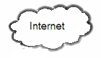

**1.6 Significance**

Almost every owner of a costly mobile handset fears the nightmare of losing his mobile phone.

I have come across many middle class people losing costly mobiles and unable to get back the same even with the help of police officers and in AFRICA there is no system in place to help such people.

Seeing their plight and the upcoming android platform which promises to be present on ever upcoming handset, this is why I proposed to design the application.

**1.7 Chapter Organization**

In this report I have briefly described about the introduction of our project, how it works, its limitations, future enhancements.

I have also explained about system problem statement and description in which I have specified the issue and the impact of the mobile theft.

I have also explained the project background that is the needs for implementing the project.

Also, the project scope, objective activities and deliverable were also been elaborated for how the project will work.

The system architecture was also been explained which shows the diagrammatic pictorial diagram of how the system will interact.

I have taken time to explain some literature review of the objective, activities and deliverables on this project.

In addition the requirement analysis and system implementation design has also been documented with accurate references.

Furthermore, The System code Implementation has been articulated and explained in detailed,

Lastly, I have documented and explained how the end user will interact with the system

# CHAPTER 2

**2.1 Historical Background about Android Technology**

Android is a new and very user friendly operating system for mobile devices which includes key applications, middleware and even uses Linux Kernel modified version. (Android, 2013)

Initially developed by Android, Inc., which Google backed financially and later bought in 2005, Android was unveiled in 2007 along with the founding of the Open Handset Alliance: a consortium of hardware, software, and telecommunication companies devoted to advancing open standards for mobile devices.

The first Android-powered phone was sold in October 2008 Ref link: [3] Android is open source and Google releases the code under the Apache License.

This open-source code and permissive licensing allows the software to be freely modified and distributed by device manufacturers, wireless carriers and enthusiast developers.

Additionally, Android has a large community of developers writing applications ("apps") that extend the functionality of devices, written primarily in a customized version of the JAVA programming language.

In October 2012, there were approximately 700,000 apps available for Android, and the estimated number of applications downloaded from Google Play, Android's primary app store, was 25 billion.

A developer survey conducted in April–May 2013 found that Android is the most popular platform for developers, used by 71% of the mobile developer population. [4]

These factors have contributed towards making Android the world's most widely used smartphone platform,[5] overtaking Symbian in the fourth quarter of 2010,[6] and the software of choice for technology companies who require a low-cost, customizable, lightweight operating system for high tech devices without developing one from scratch.[7]

As a result, despite being primarily designed for phones and tablets, it has seen additional applications on televisions, games consoles, digital cameras and other electronics.

Android's open nature has further encouraged a large community of developers and enthusiasts to use the open-source code as a foundation for community-driven projects, which add new features for advanced users [8] or bring Android to devices which were officially released running other operating systems.

Android's share of the global smartphone market, led by Samsung products, was 64% in March 2013. [9] The operating system's success has made it a target for patent litigation as part of the so-called "smartphone wars" between technology companies. [10][11]

As of May 2013, 48 billion apps have been installed from the Google Play store, [12] [13] and as of September 3, 2013, 1 billion Android devices have been activated.

**2.2 Major Android Technology Application Components**

Application components are the essential building blocks of an Android application, each component is a different point through which the system can enter your application.

Not all components are actual entry points for the user and some depend on each other, but each one exists as its own entity and plays a specific role—each one is a unique building block that helps define your application's overall behavior.

There are four different types of application components, each type serves a distinct purpose and has a distinct lifecycle that defines how the component is created and destroyed.

Here are the four types of application components:

***Activities***

An activity represents a single screen with a user interface, for example, an email application might have one activity that shows a list of new emails, another activity to compose an email, and another activity for reading emails.

Although the activities work together to form a cohesive user experience in the email application, each one is independent of the others. As such, a different application can start any one of these activities (if the email application allows it).

For example, a camera application can start the activity in the email application that composes new mail, in order for the user to share a picture.

An activity is implemented as a subclass of Activity and you can learn more about it in the Activities developer guide in this project.

***Content Provider:***

A content providermanages a shared set of application data. You can store the data in the file system, an SQLite database, on the web, or any other persistent storage location which your application can access.

Through the content provider, other applications can query or even modify the data (if the content provider allows it).

For example, the Android system provides a content provider that manages the user's contact information.

As such, any application with the proper permissions can query part of the content provider (such as Contacts Contract. Data) to read and write information about a particular person.

Content providers are also useful for reading and writing data that is private to your application and not shared.

A content provider is implemented as a subclass of ContentProvider class and must implement a standard set of APIs that enable other applications to perform transactions. For more information, see the Content Providers developer guide on <http://developer.google.com>

***Broadcast Receiver:***

A broadcast receiver is a component that responds to system-wide broadcast announcements.

Many broadcasts originate from the system—for example, a broadcast announcing that the screen has turned off, the battery is low, or a picture was captured.

Applications can also initiate broadcasts—for example, to let other applications know that some data has been downloaded to the device and is available for them to use.

Although broadcast receivers don't display a user interface, they may create a status bar notification to alert the user when a broadcast event occurs.

More commonly, though, a broadcast receiver is just a "gateway" to other components and is intended to do a very minimal amount of work.

For instance, it might initiate a service to perform some work based on the event.

A broadcast receiver is implemented as a subclass of Broadcast Receiver and each broadcast is delivered as an Intent object. For more information, see the Broadcast Receiver class on the Implementation chapter in this project.

***Intent:***

System messages which run inside the device, various applications notification such as hardware changes like SD card inserted, notifications of incoming data like SMS arrived and even application events are called as Intents.

It doesn’t only allow you to respond to such intents but also to initiate other activities or let know when particular event occurs such as suggest WIFI availability when in range.

***Services:***

A service is a component that runs in the background to perform long-running operations or to perform work for remote processes.

A service does not provide a user interface. For example, a service might play music in the background while the user is in a different application, or it might fetch data over the network without blocking user interaction with an activity.

Another component, such as an activity, can start the service and let it run or bind to it in order to interact with it.

A service is implemented as a subclass of Service and you can learn more about it in the Services developer implementation on this project.

**2.3 Services Available under Android Technology**

***2.3.1 Network***

Android based devices are generally with Internet ready. I can take benefit of internet as I wish in any level from raw java sockets to built-in Web browser which is based on Webkit.

***2.3.2GPS***

Most of the android devices have access to GPS which can tell where the device is exactly located on the earth using Google Maps.

GPS also helps in locating the desired location where I want to travel and even shows the places around us where I commonly go in everyday life which makes it easy to travel otherwise can be to locate the device and its movements in case the device is stolen

***2.3.3 Phone Services***

Android devices are similar to other phones which are typically used to make calls, send SMS and can be used for multimedia applications to download music anytime anywhere and games and everything else what I expect from a modern telephonic technology.

**2.4 Why I Chose Android Platform and Technology over Others**

1. ***Zero start-up cost to begin development with***

The tool required to develop any android applications is free of cost and Google charge very small fee deal out application in the market. [15]

1. ***Freedom to innovate***

Android OS is an open source platform which is based on Linux kernel and other open source libraries. Moreover are free to build applications which runs on android devices and even free to extend platform as well. (Grell, 2010)

1. ***Freedom to collaborate***

Android developers are encouraged to share code with others and they don’t even have to sign an NDA to do this. According to a survey conducted by Black Duck Software, the amount of open source libraries and mobile applications grew at a rate of 168% faster on Android compared to any other platform from year 2008-2009. (Grell, 2010)

1. ***Multi-platform support***

Android OS are supported on several different hardware devices including various phones and tablets.

1. ***Multi-carrier support***

Android powered smart phones are offered by most of the carrier services.

**2.5 Tracking Record on the Black Market constitute in Mobile Theft**

An insatiable appetite for smartphones has turned the black market into a global enterprise, efficiently sending ill-gotten gadgets wherever demand is greatest.

But no one has a complete picture of the size or scope of the black market. One can only catch it in glimpses.

In a report for NYPD, Timlin found stolen phones changing hand all over the city. "We saw bodegas, we saw local Laundromats, and we saw back-alley sales," he says. In March, the California attorney general announced the arrests of two individuals who allegedly paid homeless people to buy discounted phones on a two-year contract, and then shipped the devices in bulk to Hong Kong.

There, phones can sell for $2,000 each — 10 times as much as in the states. The accused allegedly took in almost $4 million in less than a year.

I hate the guys who do this type of stuff," says Marc Rogers of the online security firm Lookout. He is a hacker who frequents forums where information on the black market for cellphones is exchanged.

He says that in the global game of cat and mouse, the mouse is usually faster. For example, some European authorities created blacklists, where users could report stolen phones and block them from being used again on other networks.

But Rogers says criminals quickly realized that by shipping devices to foreign countries, they could sidestep the blacklists and probably sell for close to retail price.

Law enforcement tends to focus on thefts on the street and in subways. But Rogers believes police will only make progress when the black market itself is squeezed.

He says the security features in Apple's new operating system, like fingerprint ID and the requirement that you enter a password before resetting the phone, are a good start.

"Ultimately, it would be fantastic if I could get it set up so once a device is stolen, the only value there is from the parts," he says.

New York police will be on high alert when Apple's new iPhone goes on sale Friday. Since the first iPhone debuted six years ago, they've noticed that every new Apple product comes with a spike in street crime.[16]

# CHAPTER 3

* 1. **OBJECTIVE**

To research on the issues faced with mobile theft, the growth rate of mobile phone usage as compare to PCs and Laptops, Physical and data Security issue with Mobile.

* + 1. **Activities:**

1. Investigate the trend of World black market activities relating to mobile phone Document the number of stolen mobile phones that wind up in pawn shops, sold on the street corners or in online classifieds.
2. Investigate the number of stolen mobile devices that are shipped to international markets (particularly countries in Africa, Latin America, and Asia pacific).
3. Document the trend of Anti-theft mobile response activities in Africa.
4. Evaluate the use of mobile SMS as an integral part of mobile devices and mobile applications.
   * 1. **Deliverables:**
5. Data showing the trend of mobile phone theft and re-sale on the world black market
6. Data map showing the number of stolen mobile devices that appear on international markets
7. Information on Anti-Theft Mobile responses in Africa
8. Documentation on the use of mobile SMS by mobile device users
   1. **OBJECTIVE**

To build an Android client application which will automatically send SMS when SIM card is changed and also when user needs to know the location of the lost or stolen mobile phone.

**3.2.1 Activities:**

1. In this project I am going to examine how SMS technology via the APIs provided by Android can help us in track the location of the stolen or lost phone.
2. This project will get information from the user on installation; this information will be used to capture all the information about the phone; like the IMEI which is unique per phones.
3. Get the user relative phone number for receiving SMS in case the phone get lost.
4. SMS function which will send automatic SMS text message to an alternate phone number immediately when SIM is swapped on the registered for phone.
5. This app will take the relative phone number at first registration on the platform and store in a database.
6. When the user phone get lost or stolen, then the application will launch the SMS automatic process from the lost or stolen mobile phones with the number the user entered during the registration.
7. Finally it will send a “report of a stolen or missing phone” message to the alternate phone.

**3.2.2 Deliverables:**

1. Users registered with unique identification on the application.
2. SMS messaging services in the MATS for sending and receiving SMS in a stealthy mode incorporated into application.
3. The Application is able to sends Automatic SMS as soon as SIM swap happened the lost or stolen phone in a stealthy mode.
4. When requested the application sends the location of the lost or stolen phone via SMS
   1. **OBJECTIVE**

To design an application by means of which I can track the location of the mobile phone of the desired user when it been stolen or lost.

* + 1. **Activities:**

1. To track the location of the smart phones.;
2. The project will consist of Android client application which will send an SMS when user requested for the phone location.
3. I am going to use position tracker functionality which works on GPS (Global Positioning System) and GPRS on any smart phones. This will be used to fetch the latitude and longitude satellites of the location of the mobile
4. Send the location information and via SMS to the requestor phone from the stolen phone
5. Moreover if mobile is connected to the internet it will retrieves the postal address from Google maps. (ZHANG Hao, 2011) and send the retrieved location address to Relative number.

* + 1. **Deliverables:**

1. Use goggle or yahoo position tracker to get the location of the stolen or lost phone
2. Get the location through google map in case the stolen or lost phone has internet connections.
3. The application retrieves the location of the lost or stolen

# CHAPTER 4

**4.1 Introduction on Requirement Analysis**

The Requirement Analysis Documentation is nothing but a method of communicating what the whole project is about.

Objective, realistic and complete are the important factors to kept in mind while writing satisfactory documentation.

The whole process of implementation, operation of system and development is based on a proper documentation.

Therefore, the whole idea behind this project requirement analysis document is to represent the bounded physical representation of the body of information what I am trying to design will have the capacity to communicate the intended design of the project.

This document produces an artifact by collecting and representing information.

This document helps my supervisor to understand about the project in a lucid manner.

Its gives an overview of the existing system and how the proposed system will leverage on the existing system and also add its own functionality which is not available on the existing system.

In addition, it’s contains the technology used and the hardware and software use in developing the application.

Finally, its justify the feasibility of designing the project as related to the economical , technology, behavioral aspect of the entire project, in conclusion it contain the requirements specification document which will be used in designing the prototype of the implementation of the project.

**4.2 Existing System**

There are lot of Mobile Anti-Theft software available in the market today, and all comes with their targeted functionality and platform, most effective mobile anti-Theft software has the basic functions and objective which is to check the position of a mobile phone, but majority of the software lack the main concept of the Anti-Theft system and the feasibility of detecting theft using the software.

Therefore, the proposed Anti-Theft Software will cover all the major flaws that those software was unable to capture. Example, the proposed application can be used has a mobile tracker.

**4.3 Proposed System**

MATS would be widely used as people are concerned about their mobile phones.

Moreover the software would be designed to use very less memory and the package can be downloaded over internet via google play store.

This system can be used by concerned parents to track their children at any moment of time without their notice. Employers can track employees as well.

After owner of a mobile phone install the Mobile Anti theft System on his mobile phone, and the application is put to start by filling all the necessary information like his alternate number, his username and password which will be used to check the state of the phone and update his or her information and commit the information into the application database.

When he loses his mobile phone, he waits for SMS from the Mobile Anti-Theft Software.

When he / she receives that SMS, then he starts corresponding with the Mobile Anti Theft System via requesting or postal address etc, relative of the owner can request for the location of the mobile phone either the mobile phone is lost or not, he acts as the master to the Mobile Anti-Theft System; supposing a scenario wherein the thief hasn't change the SIM, that allow the relative to request for the mobile location.

If in a normal scenario where by Thief changes the SIM of the Mobile phone and reboots the mobile phone on rebooting the mobile the Mobile Anti-Theft system will automatically triggered and intimation will be sent to the alternate phone number.

I belief the Mobile Anti Theft System would be widely used as people are now concerned about their mobile phones.

Moreover I will make the software to be downloaded over the internet with less phone memory usage.

**4.4 Feasibility**

MATS would be widely used as people are concerned about their mobile phones, as I have stated on my investigation on the mobile theft issues faced all over the world, that all people care for is the data and not the phone itself.

Since the technology is an open source which is free of cost, therefore, I wouldn’t need to invest money to develop the application, in addition, with my several years of experience with developing application under java platform the backbone for this development is mainly on java. Therefore, the software would be designed to use very less memory and the package can be downloaded over internet via google play store, and most importantly be intuitive enough to interact with.

**4.4.1 Technology**

**ECLIPSE IDE**

Eclipse is an Integrated Development Environment (IDE) and an extensible plug-in system which is primarily written in Java and Java applications can be created. The Eclipse IDE serves our development environment for designing and testing the application.

**JAVA**

The Primary activities like sensing the phone turn off and on, SIM changed, Available credit on the newly inserted SIM and send message to alternate phone is done with Java Technology under android SDK

**XML**

XML will be used for representing subjective data structures for communicating between the lost phone and the alternate phone by requesting and responding to services request.

**GOOGLE MAPS API**

offers services like street maps, navigation planner for travelling from source to destination by foot, car or any public transport and even helps in locating shops, restaurants , cinema and many other across the world this service will be used to locate the lost or stolen phone postal address.

**SQLLITE DATABASE**

**SQLite**

It will be used to capture information needed to recover the lost or stolen phone, please its act has the data store for request and respond to information require. And it directly embedded into the android phones.

* + - 1. **Hardware**

The hardware requirement for the MATS is an important part of the MATS standard.

The requirement is stated below

1. Any android mobile phones with ARM processor, GPS and GPRS support.
   * + 1. **Software**

Though the java cross-platform nature of java helps alleviate concerns over the wide range of mobile device operating systems. Even, so the Android specification lays some ground rules about what is expected of the operating system in android devices. Therefore, for are the major software specifications for the proposed system (MATS).

1. Minimum Version Google Android OS 1.5
2. A mechanism to read from and write to non-volatile(persistent)memory
3. A timing mechanism for establishing timers and adding time stamps to persistent data.
4. SQLlite database

These requirements, although are somewhat minimal, still provide a reasonably rich set of features that are available for use by MATS application.

# CHAPTER 5

**5.1 Introduction**

Design documentation is used to design the prototype of out the final document will look, therefore, in this chapter I have documented all the preliminary designs which comprises of all high level design of the system.

These are Database, Communication and Interface modules, also the low level core design which is of course the low level design of the system, in the low level design have took time to explain the all the functional and nonfunctional aspect of the system and how activity related to one another, and how the data flows between one another to another, the designs includes; Use Case diagram, Data flow diagram, and Entity Relational Diagram.

**5.2 Preliminary Design**

The Mobile Anti theft project contains 3 modules.

* **5.2.1 Database Module**

This module is used to fetch the real data from user and store into database using SQLLite. In this module first user interface where user provides SIM IMSI number and alternate number then click submit button. Next it will store information in the database. The users can fetch the information from database to bind user interface control.

• User can enter name, alternate number and IMSI number.

• User can change the alternate number and IMSI number.

* **5.2.2 Communication Module**

This application needs to be installed on mobile. The software helps us to obtain the current location of the phone using GPS facility and retrieve postal address with GOOGLE Maps using GPRS facility.

* **5.2.3 Core Module**

We are using an Android OS service which will be acting as a communicator between device app and SQLLITE Server database in Phone.

This service will receive information as data and store in the database. This service starts automatically in stealth mode and check the SIM IMSI Number with the database.

If SIM IMSI Number does not match with the database, it sends a SMS to alternate number stating that SIM has changed else reboot normally. It always checks the SMS whether SMS contains query string that start with MATS or not?

If SMS contains query string then it will respond with the result in stealth mode (means thief does not know about the message).

**3.3 Design Considerations**

* **3.3.1 Input**

• IMSI (International Mobile Subscriber Identity) number of the SIM.

• Alternate number of the Owner.

• Name of the Owner.

• Pre-defined text that will send to alternate number when SIM will change.

• SMS that contain query string.

* **3.3.2 Output**

• Text message stating that SIM has changed.

• GPS Location of phone.

• Postal Address of the phone.

**5.4 Use Case Diagrams**

Use case diagram here shows the roles of all the people involved in this project. Here in our project we consider 3 cases they are owner, relative and thief.

RELATIVE

OWNER

THIEF

From the above use case diagram we know that the owner can register the details in the database when software is installed and at any point can retrieve the details and if necessary can change it accordingly and relative receives SMS, GPS co-ordinates and postal address whenever the change of SIM is done and thief doesn’t play a role in this but he is related with changing SIM and rebooting as soon it’s done, relative of the owner will get the details accordingly.

**5.5 Data Flow Diagram**

* **5.5.1 Foreground**

The foreground includes the user interface of the application. Whenever the user opens the application it ask for login and if it’s a new user then ask for user account creation. After the user has created his or her account, user may never open the application again, if require user can update his or her record this module is only accessible by the user. The application will all run at boot up without the knowledge of the user.

Above is the Dataflow Flow Diagram for the Foreground activity in the application:

Owner Database

Create Account

Owner Database

Owner Database

Owner Database

* **5.5.2 Background**

The actual process running on the background is not known to the user. He only enters the required information when registering and saved to the application. Whenever the phone bootup the application will all check the mobile IMSI and if it’s same as the stored data then it doesn’t start any events. In a case if the IMSI stored is not same as current IMSI on the phone, the application will act and perform some events which will occur without the knowledge or without any hint, then sends SMS to the alternative phone number stored by the owner.

Booting

Owner Database

Owner Database

Owner IMSI = current IMSI

Theft Database

Theft Database

Theft Database

Owner Database

**5.6 Entity Relationship Diagrams**

Entity Relationship is used to show the relation among entities in a program, it also shows the strength of their relation, be it strong or wick relation. Below diagram show the entity relationship for the proposed application, Note that entity could exist from internal or external object.

1

Has

**MOBILE DEVICE**

**THIEF**

**SIM**

Come across

Has

n

1

n

Has

n

Has

**RELATIVE**

**OWNER**

Has

1

1

1

n

n

Has

1

1

n

n1

11

# CHAPTER 6

**Introduction**

Implementation means to carry out or to put into effect. The implementation phase of the system of any software is to obtain source code from the design specifications. Implementation becomes necessary to obtain source code and related internal documentation required to understand the system and be demonstrated easily. Documentation and code is written in a way so that testing, debugging and modification become easy. Post-implementation is nothing but an evaluation in which we can verify that objectives of the project is met completely and to check if actual cost of the project does not go beyond initial evaluation. It can be even stated as review about the problems which need to be converted for the success of the project. Once implementation and conversion is done, review is conducted to check whether the system meets all the expectations and is changed if any improvements are required. Post implementation also measures performance of the system against pre-determined necessities and also checks if any modification or re-design necessary.

**Database module**

Here in this module we develop a database using sqllite database which has one relation to store name, password, IMSI, relatives’ phone number. We connect to sqllite database through java and commit values into database. Again when the phone is rebooted this database is opened and queried for IMSI number if it matches then we close it else we fetch relatives phone number and send an SMS to that number.

**LoginDataBaseAdapter.java class**

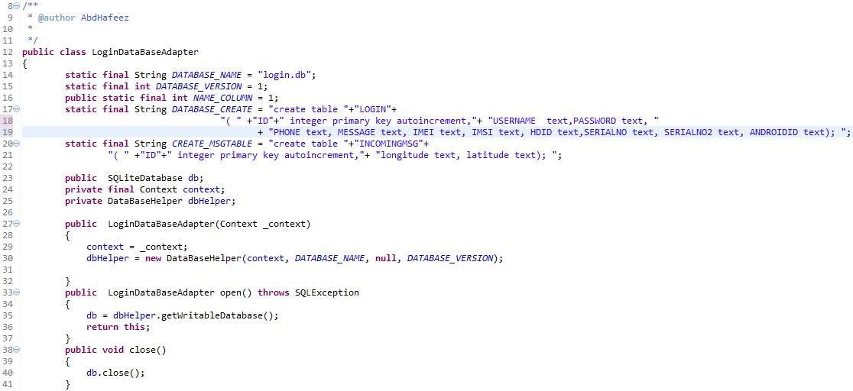

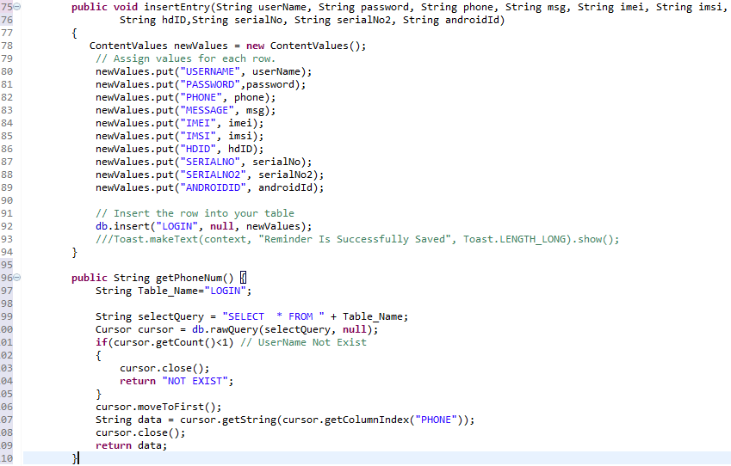

The above code is used to create a database, connect and disconnect from the MATS database, the declaration on line 12 is used to declare the name of the class for the MATS database as Login Database Adapter.

The line 14 is used to declare the name of the Database as ‘login.db’, line 15 declare the sqllite database version, the 16 declare the column name, also, line 17 is used to create the database table as LOGIN, note that this method is the same as creating table in normal sql query.

The line 27 is used create a constructor for the database class, the purpose is load all the property such as the application context, the database name, and the version of the database. of the database as when called.

The method in line 33 is used to establish connection to the database using open() method, inside this method we have the getwritabledatabase() method is called in it, which is used to open the database for read and write permission. The method also throws any known exception in case the DB failed to connect.

Line 37 is used to disconnect or close the connectivity to the database after use, this is necessary because of security issue.

The insertEntry() method in 75 is used to insert the obtained records such, Phone IMEI, SIM IMSI, username, Phone serial number e.t.c, and get stored in the LOGIN table. Please note that some information are such as username, password, relative phone number are obtained directly from the user while, the IMSI and IMEI are auto generated using System inbuilt functions.

The method getPhoneNum() in line 96 to 110 is used to query the database table and retrieve the relative phone number.

**Core Module Implementation**

This module is related to user interface. Getting user input, validating it and then connect to database module to commit the same if already registered user has to enter valid password to gain access to interface.

**MainActivity.java Class**

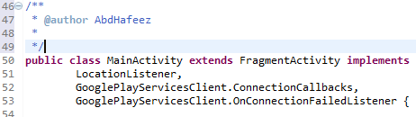

The code above is used to define the MATS Home Screen, its extends Fragment Activity for designing the interface, and implements LocationListener, GooglePlayServicesClient.ConnectionCallbacks, GooglePlayServicesClient.OnConnectionFailedListener Interface API for getting the location from google play.

**The onCreate(Bundle saveInstance) method**



As shown above the onCreate() method is called from line 85 to 170 is used to initialize all the activity component when the application is trying to open, some of the components includes the TextView, Button, Location Manager and main fragment activity.

**add_Phone(View v)**

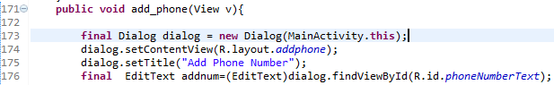

the add_Phone(View v) method is a submit button implemented as part of the component of the main activity for adding extra Relative contact to the application.

**Onstop() Method**

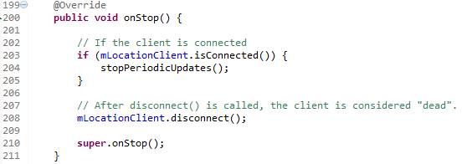

This method is an inbuilt Activity API method used for overriding the Activity lifecycle, this particular method is used for stopping any runtime component before stopping the main activity, it is useful for handling linkages on the application. Here I used it to disconnect the location connection component for conserving phone battery.

**onPause() Method**

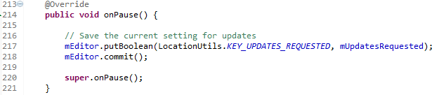

This method is also part the activity method state lifecycle, it is relevant for the current state of the activity component before it get deployed, here I used it to store the connect GPS state in a content Receiver for future use.

**onStart() Method**

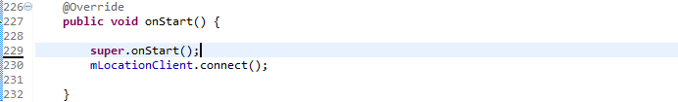

This method is was used to automatically connect to Location Manager for searching for the current location, even if the GPS device is disabled. It is part of the Activity lifecycle which is called when phone is starting up.

**OnResume() Method**

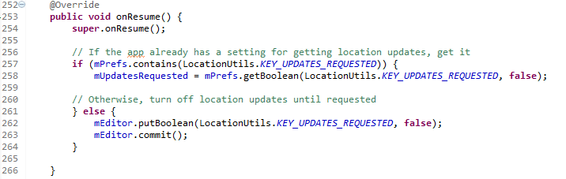

The onResumed() method is also part of the category of the Activity lifecycle which is called as soon as the activity leave the onPause state. Here, I used the method to get the last location which is stored on the Content Receiver in onPause() method, and continue to make the activity location component to get the lastest location update.

**getLocation() method**

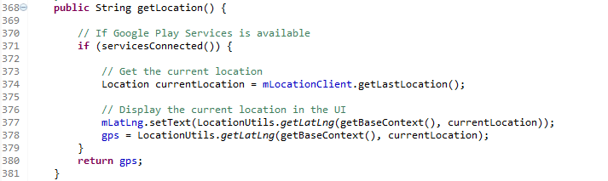

The getLocation method is a user define location for checking whether the google play location service is currently connected and retrieve the current GPS location from it.

**getAddress() method**

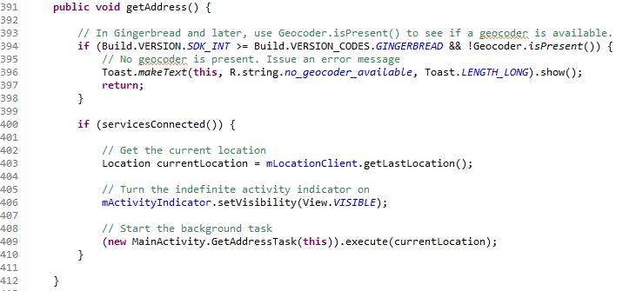

The getAddress() method is also a user define method, its user the current android system installed Google play service to retrieve the current address from Google MAP over the Internet.

UserData Class

The userdata class is used to capture data required for interacting with the MATS from the user, its captured userid, password, relative contact and message from the user and automatically generate the phone IMEI and SIM IMSI from the phone operating system saving the user time from searching for this information on the phone input it accordingly. Then, get it committed into the SQLlite database table created.

Below are the methods and field used in gathering the information.

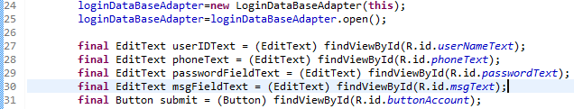

The code in line 24 and 25 are used to instantiate the database class and open the database for read and write permission.

The code in lines 27 to 30 are used to create four (4) fields namely; userIDText, phoneText, passwordFieldText and msgFieldText respectively. While the code in line 30 is used to create a submit button called submit for committing all the values into the MATS database table.

Validate and saving the information onto the Database

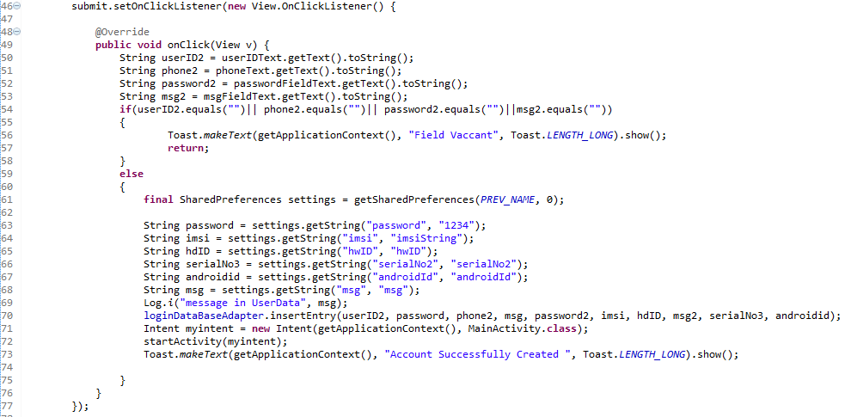

The above are used to check and validate the inputted value whether they conform with the exact way we want the details to be filled before saving them onto the database, the conditional statement in line 54 does the validation.

The code in line 70 calleds the insertEntry() method we’ve create in the Database class, and pass all the require parameters to the method and the loginDatabaseAdapter object used it to save the data onto the database table.

**Communication Module Implementation**

This module deals with communication. It intimates the relative on SIM change, responds to incoming SMS, gets the GPS co-ordinates and sends it to the relative, connects to internet sends the GPS co-ordinates to Google maps and gets the postal address from it and forwards it to the relatives phone number. The communication here is with satellites, with the other mobile phone and on internet.

**The GetAddress AsyncTask Class**

This class is used to work on the background and query for the GPS coordinate and the Postal address then handed it over to the required class for further processing

**doInBackground() method**

This method does exactly as its name suggest does all the checking in a silent mode without interference with the current activity to retrieve the GPS coordinate and Postal address with reverse geoconferencing mechanism.

**Receiver Class**

The Receiver is a class which extends the broadcast Receiver API class for receiving any notification such incoming SMS, Email, battery drainage, SIM change and so on.

Therefore, I implement this class to handle all the incoming SMS alert and respond if the SMS body conform to the predefine query.

onReceive() Method

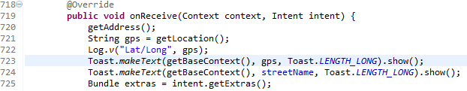

The onReceive() method foes all the operation stated above, please note that this method only execute at intervals for which the operation needed to execute.

**MyReceiver Class**

This is another Broadcast Receiver class which extends the BroadcastReceiver API class and Implement the onReceive() method for check the SIM state, and act according to the given query. In case the SIM is swapped its automatically send ad SIM to the relative phone number.

**MyService Class**

This is a service class it extends the Intentservice API class on android to implement steady state service for checking the phone state at bootup and notify the broadcast receiver to check the current SIM against the registered before the phone rebooted, this operation is done before the phone completed its boot sequence in a stealthy mode.

**The Manifest File**

This file contains all the components of the application attributes. All Android application will have AndroidManifest.xml file in its root directory. All the information about the application should be presented to android which is done by this manifest file, so that the application can run successfully on android. What the manifest file does is explained below;

1. It creates java package name for application which acts as a unique identifier.

1. It describes the components such as services, receivers, activities, broadcast and content providers which are collected in application and also the names of classes which employ all components and publish their capability such as which Intent can they handle.
2. It also determines which process host application components.
3. It declares permissions in order to access protected space of API and also with which applications it can interact.
4. And also declares permission in order for other applications to interact with its components.
5. The minimum level of API that the android applications require.
6. Lists linked libraries of that particular application.

**<application> Tag**

This is a container tag which defines the application components viz services, activities, receivers, content providers and permissions.

**<service> Tag**

Service is declared as application components. Services doesn’t have visual user interface like activities. These services run in background or as a rich API which can be called by other applications. In manifest file all the services should be represented the one which are not tagged will not run at all.

**<activity> Tag**

Activity is a part of the visual user interface which implements parts of the

application. Same as service it should be represented in manifest file or else will not be run.

**<Receiver> Tag**

The Receiver class is declass as application components, which receives all broadcasted notification on the application and act on it less than 10 seconds, its has no visual display.

**<Use-Permission> Tag**

It is a security component of the application, which the android OS check before installing the application, in order to notify the users what and what the application will access on the phone, in the application I have numerous permission setup.

# CHAPTER 7

**End user Guide:**

Below is the end user oriented documentation for using Mobile Anti-Theft System.

After the Application is stalled on any android device, the first interface you see is the Main Interface which consists of User Login and Signup Button, below screenshot depict the Main Interface. The login button is on the left while the Sign up Button is on Right; this design is imitated from the Twitter Main Interface Design.

**Main Interface**

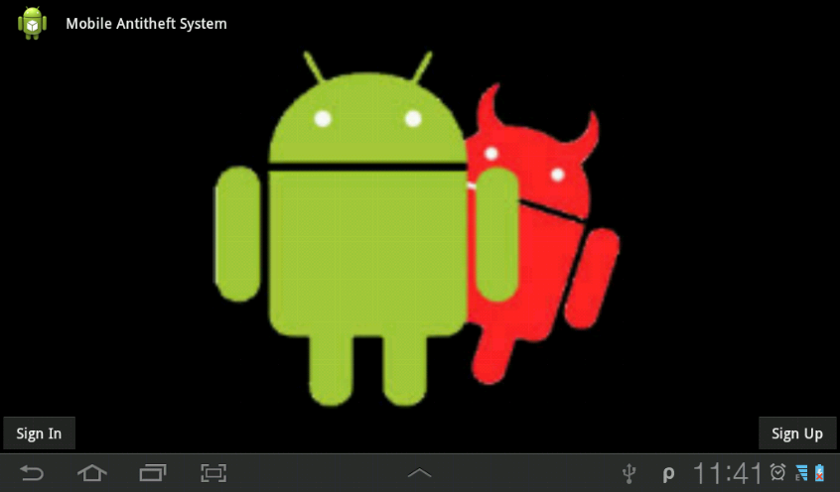

Sign In Button

Sign Up Button

* + 1. **Signing Up to MATS**

1. Select sign up button located at the right down corner on the interface, this will display the sign up form interface, as shown below.

**The Signup Form Interface**

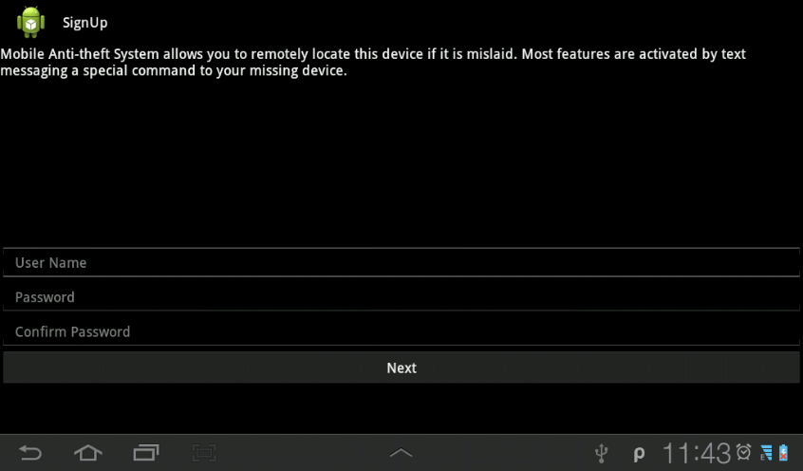

1. On this interface user is required to type his / her user name, password and retype the password to confirm the password conformance.
2. Click on the Next button to go to the next interface, where user will enter the Relative contact and the contact message, the next interface is show below.

**Adding Relative Contact Interface**

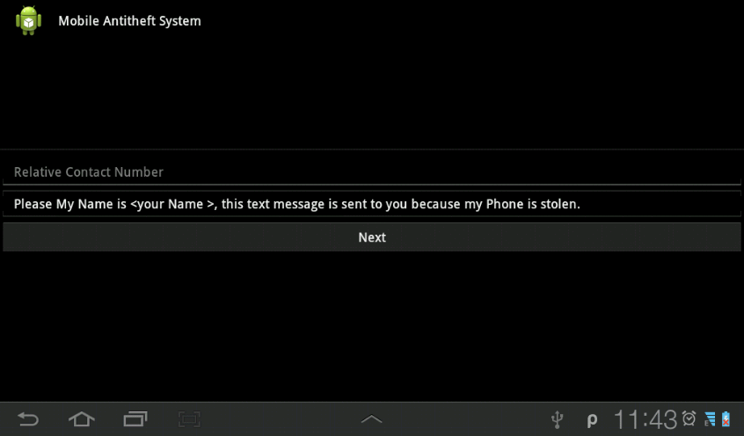

1. User is required to enter the relative contact number on the field nd move to the next field,
2. The second field allow user to Edit the sentences and put his / her name of the <your name> field in order to communicate effectively to the recipient/buddy.
3. Then user should click on Next button to review all the data entered for confirmation below committing to the database.

**The confirmation Interface is shown below.**

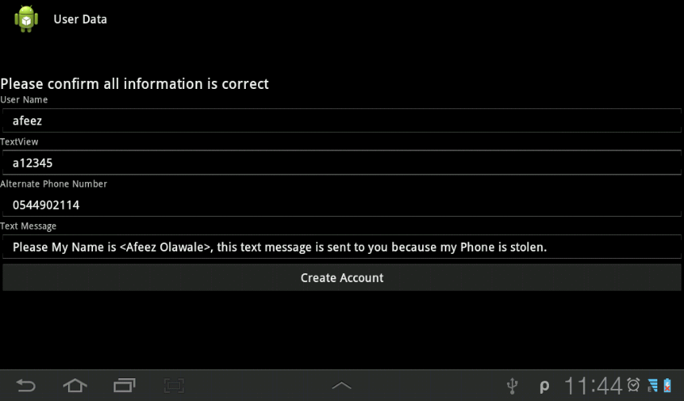

1. After all information entered confirms to be okay, then user click on Create Account Button to finish the signup process. At this stage system will switch to monitoring mode and start monitoring any Theft on the Device.
   * 1. **Logging onto the MATS**
2. select the Sign in Button on the down left area of the screen, this will display a popup as shown below

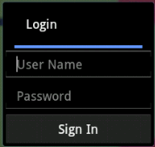

1. On the popup login Dialog user needs to input the userID and Password created while signing up on the system, then click on Sign In to logon to the User monitoring console.
2. Once successfully logon, user will automatically navigated to the User monitoring console as shown below.

**User Monitoring Home Screen**

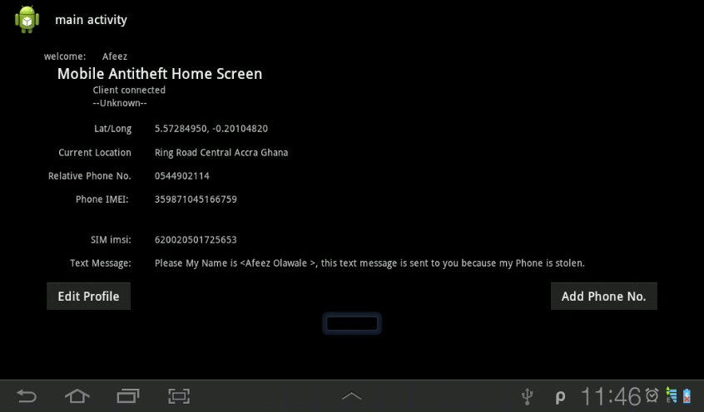

User monitoring Home Screen is shown above, user can edit is profile and add more relative phone number on this interface, below guide is used to Edit and Add more Phone Numbers.

* + - 1. **Edit Profile**

1. To Edit Profile select edit profile button, this will take you to the user profile interface, which contain the current user information, below screenshot show the edit profile interface. Therefore, user can edit the username, password, Relative contact and Text message respectfully.



1. After user is done with editing the profile, then click on create account button, the information get updated on the database and on the User Home Monitoring screen.

**7.1.2.2 Add Phone Number**

User can as well add more contact information some that more people could receive SMS from MATS and interact with it accordingly. Below outline the process of the adding more contact

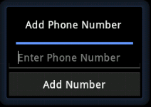

1. On the Add Phone Number Dialog box, enter the new phone number on the text field
2. Click on the Add Number Button to add extra phone number.

# Conclusion

On theft detection my Application system would send an SMS to the owner alerting him of the phone number of the thief without the knowledge of thief in stealth mode.

Then our system would retrieve GPS co-ordinates from satellites and then send a SMS within a second.

Then MATS (Mobile Anti-Theft system) would connect to internet and send those GPS co-ordinates to GOOGLE MAPs and then using Google maps API, it would retrieve the postal address of the stolen phone and send it as an SMS to the relatively stored number, this functionality is not found on any of the existing anti-theft system.

Now the application is working for Device application, It’s has localized system functionality and also accessing the details anywhere in the world making it an internationalize application.

Later I can implement some telecom concepts, so that the user will get the information about the activities of the company in a mobile device. As technology and requirements are changing day by day, I can add more functionality and implement the system with new requirements. The system is designed in such a way that it is flexible to change any further requirements Prescribed by the user.

# References:

1. Godfrey Ikhemuemhe, 3/oct/2003, http://allafrica.com/stories/20031013292.html

2.http://siteresources.worldbank.org/EXTINFORMATIONANDCOMMUNICATIONANDTECHNOLOGIES/Resources/282822-1346223280837/MainReport.pdf

3. http://www.openhandsetalliance.com/android_overview.html

4. http://www.developereconomics.com/reports/q3-2013/

5. http://www.canalys.com/newsroom/google%E2%80%99s-android-becomes-world%E2%80%99s-leading-smart-phone-platform

6. http://www.phonearena.com/news/Android-steals-Symbians-Top-Smartphone-OS-crown_id16332

7. http://arstechnica.com/gadgets/2012/11/on-androids-5th-birthday-5-things-we-love-about-android/

8. http://www.androidpolice.com/2010/05/01/custom-roms-for-android-explained-and-why-you-want-them/

9. http://techcrunch.com/2013/07/01/android-led-by-samsung-continues-to-storm-the-smartphone-market-pushing-a-global-70-market-share/?ncid=tcdaily

10. http://news.cnet.com/8301-30686_3-20092399-266/google-just-bought-itself-patent-protection/

11. http://www.tomsguide.com/us/google-android-installations-app-downloads,news-11861.html

12. http://www.youtube.com/watch?v=1CVbQttKUIk

13. http://www.bbc.co.uk/news/technology-22542725

14. (Murphy, 2008)

15. http://www.androidpolice.com/2010/05/01/custom-roms-for-android-explained-and-why-you-want-them/

16. ILYA MARRITZ http://www.npr.org/blogs/alltechconsidered/2013/09/16/222125010/dear-apple-good-luck-against-the-smartphone-black-market

17. http://developer.android.com/guide/components/fundamentals.html